Welcome back to the part 2 of the previous lesson where we are creating an animated user interface

00:08

For like an Iphone



The above is the animation that we created in part 1 of the lesson it just sort of brings in as of animated background and its bringing in different user review elements and now in part one we downloaded the tilted phone as shown below

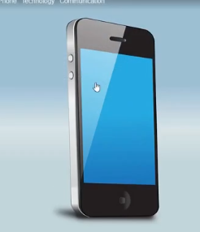

Its actually a vector image of an iphone and we are now going to bring this vector image into natron and then we are going to map this screen and hten we are going to map this screen(maybe that we animated) so that its relative so that it’s kind of fits we are gonna use the corner pin node to fit this flat image (maybe we animated ) here to an angled Iphone screen so since we have illustrator file and we need to open it in Illustrator but we can open it in Inkspace so we drag and drop the tilted image illustrator file on top of the Inkspace new document and there will be an import window as shown below also uncheck the imported pages (maybe by this no extra white page will be there for that image (who knows))

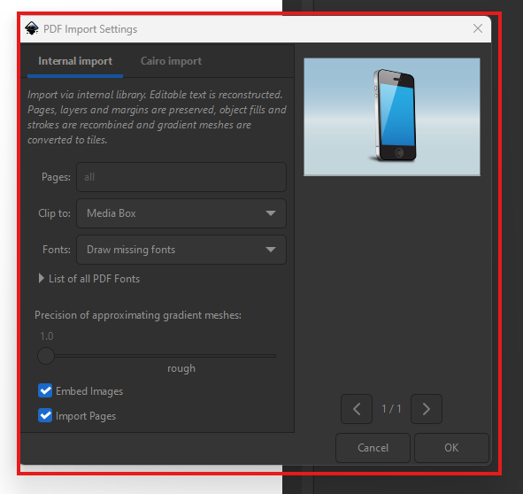

Click on OK button it will be imported and it will now look like below

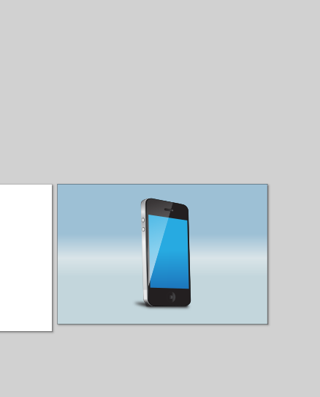

Now we ungroup it by **ctrl + shift + G**

Now after ungrouping image looks like below

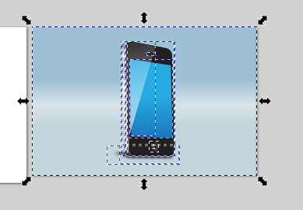

I think it is already ungrouped so we don’t need to do it at all select the background and delete it

Now our phone look like below

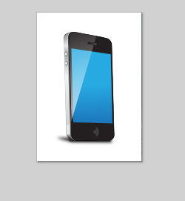

Now we save as our file and save it as Inkspace svg so now we have our svg file in the specified location as marked below

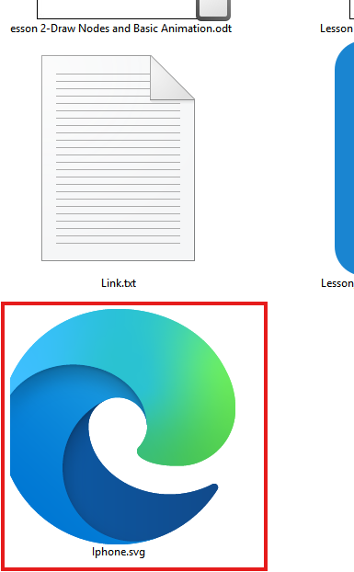

Lets read in this iphones svg image and we add a new merge node and connect it to the merge node where we added animation and then add iphone svg read node to the A pipe of new merge node Now our node graph look like below

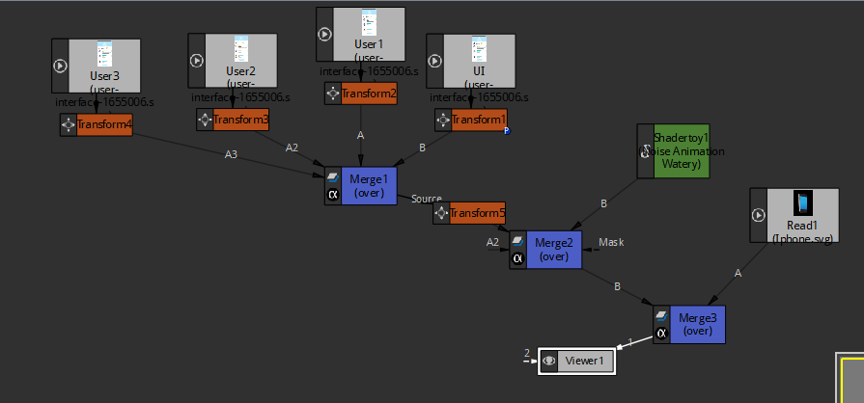

And our viewer look like below

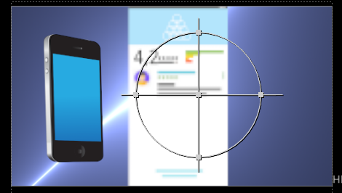

2:43

So we have lot going on here So what we want the UI screen we animated to the the phone screen as shown above in the right side. Actually this screen Now on the screen we have transform on it as marked below in the node graph

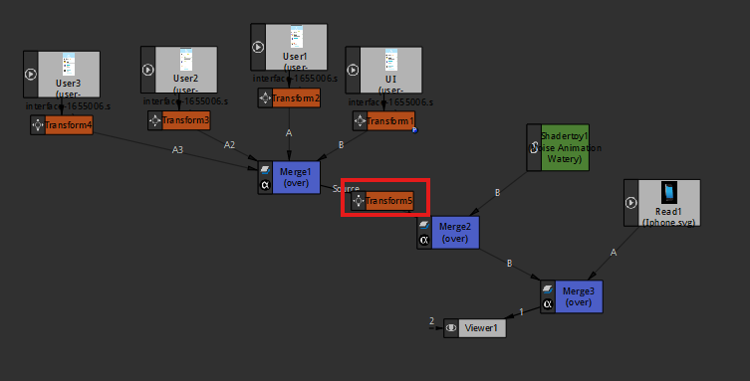

If we disable the marked above transform if we hit the d key then you can see the it get shifted to the bottom left as shown below in viewport

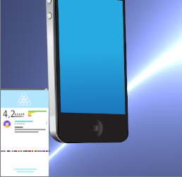

We now delete that transform as we don’t need it to be there now so it will be for long time will be in bottom left as shown above. Now our node graph look like below

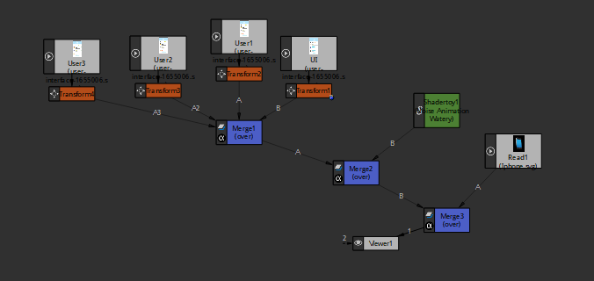

Now the UI we animated is coming below the phone svg we imported

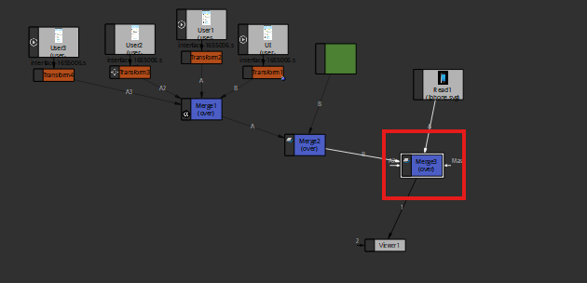

Now we remove this marked above merge node and place the phone svg and as the A of the merge node in the left of marked above and connect the merge node of animated as the A2 so that it can be on top of the phone. Now what we want to do is add a corner pin node lets take a step back here and see where we want to add this corner pin so what we want to do is we want to take the UI marge node and add corner pin to it now select the UI merge node and then press tab key and then type corner pin as shown below

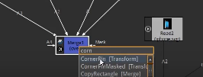

And then it will be shown in the option press enter on the cornerPin (transform) and cornerpin (transform will be added to that merge node) Now our node graph will be like below

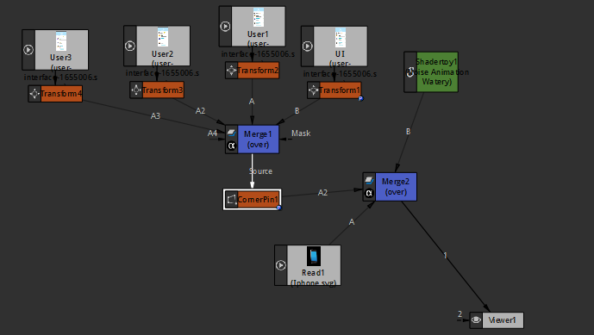

4:29

Now what it will do is add different points on the corner of our image on which we applied our corner points as shown below in viewer panel

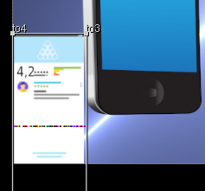

And we can move it to the corners of our screen suppose we move a corner point of the UI screen suppose we move top right then it will look like below

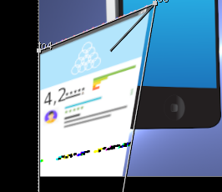

You can see aboe it is being distorted this distortion will help us to place the UI to the screen

And it will be distorted for a second until we get all four of them in place and that’s going to move basically that our view to match the view of our screen so we get it right Now you can zoom make sure that no blue part of the screen should not be covered. We are just going to cover it up completely and these corners Now after doing everything now our screen look like below

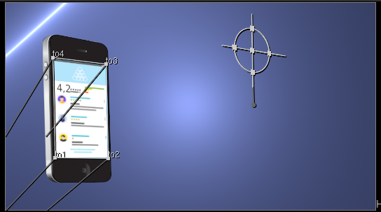

**Note:-**

The size of gizmo of corner pin depends on where the components of the image are at the point in the timeline when the corner point node are added

5:14

Now our animation will still play but now its over the top of the phone screen as shown below



Because we used the corner pin tool to reorient this our image and animation of our interface and then we can do before we get to viewer or actually

Now we add another merge node to the merge node that has Shadertoy and Iphone now in this merge node add the shaderToy to the new merge node by removing it from the merge node that has iphone and then then add trandform to the merge node having the Iphone now

Now node graph look like below

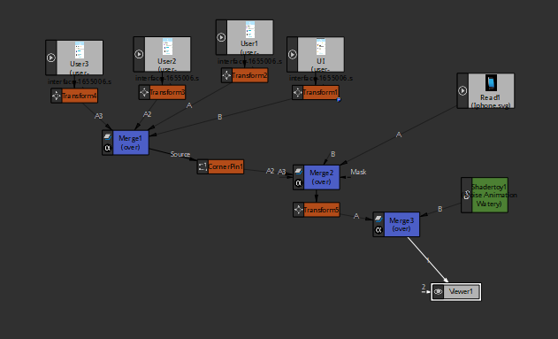

So that’s what it is going to let us do is Now we can move our whole Ui and the phone together as shown below

Now we animate the Phone such that it move from left to right a little so we will start at frame 1 and our phone will be in left and then add keyframe for translate at frame 70 our phone is in right

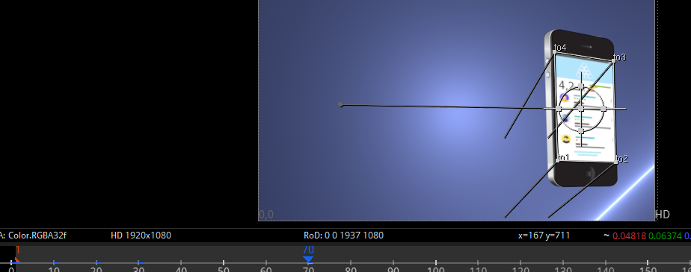

And then maybe also lets go back to frame 1 and we can rotate that a little bit too just to give it some extra life now in frame 1 add a keyframe for rotation and then to frame 70 add keyframe with a slight rotation(Teacher just add keyframe in 70 maybe it used to happen in previous version but if I add it directly in 70 then it will be rotated at an angle from frame 1 to 70) like below

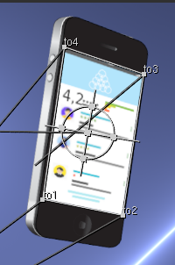

7:06

Now our animation look like below



SO now we render it out by writer node and we connect the writer node to the last node the viewer connected to do that it can get the data the viewer node is seeing and then in project setting make sure that the frame range we choose the range we have done animation on so in our case it is 70. As markwed

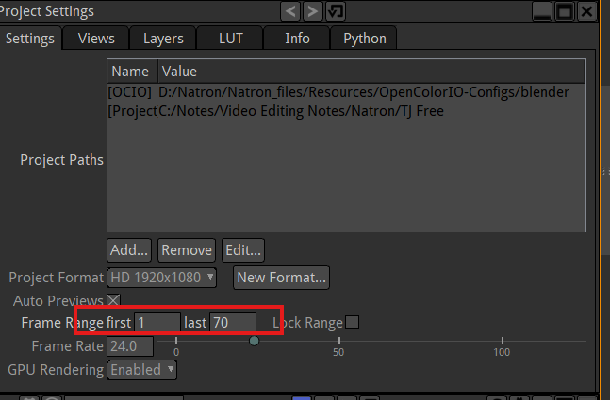

If you cannot see project setting then go to Display -> Show Project Settings

And Teacher find out why we could not find them or why the project setting sometimes disappears

Because in top left corner of the properties as marked below

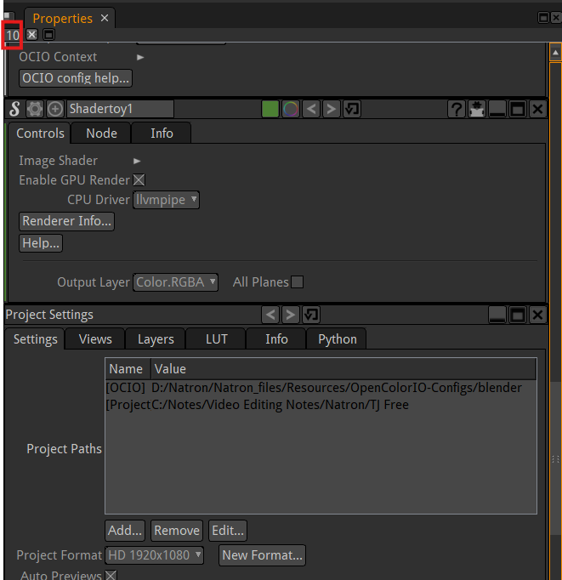

We have our default we are only seeing 10 (in marked above) windows at a time son we had opened up more than 10 so we could not find it so we changes to a number more than 10 like 15 then we will see 15 at a time. So make sure increase it if the number of panel exceeds the limit then remaining panel will disappear even if you exceed the limit later you need to bring it back by double clicking on the node or bring project properties back.

8:25